1.Created Resource Group: Prashanth

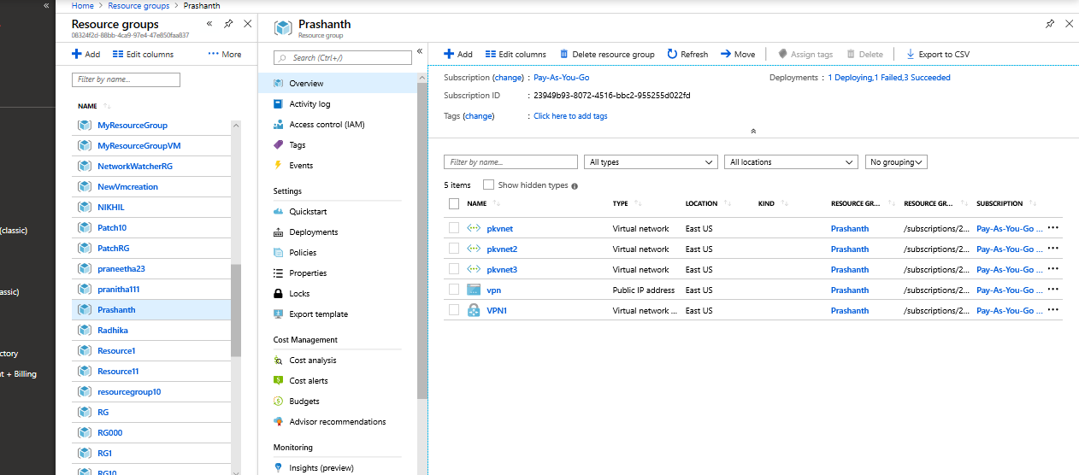

2) Created Vnet by name pkvnet

3) Created Vnet by name pkvnet2 & pkvnet3

5.Created VPN Gateway By name VPN1

5.Created VPN Gateway by name VPN2

7.Established connection from Vnet1VPNGateway to Vnet2VPNGateway

8.Established Vnet peering between Vnet2 and Vnet3

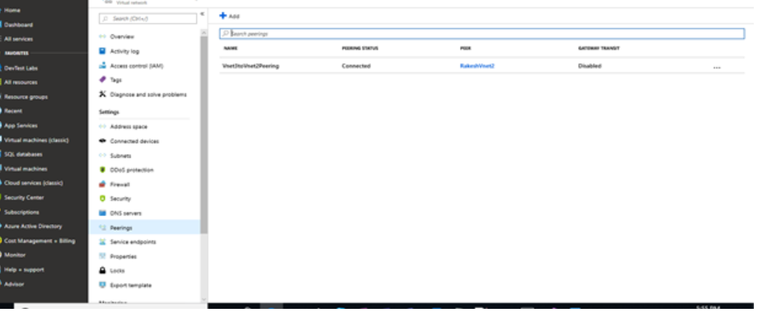

9.Established Vnet peering between Vnet3 and Vnet2

